Fairies and Their Friends in Merion Botanical Park:

Solve these riddles and you’ll find all the fairy houses. All of them are visible from the lawn side of the park and are listed in order from the City Ave. end of the park towards the post office.

You can also find these riddles on the Botanical Society of Lower Merion facebook page and web site. See bottom of the page for links.

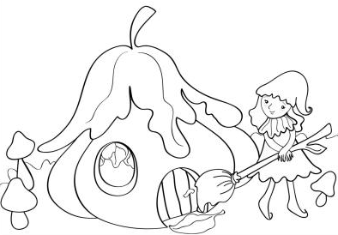
Please make sure you do not touch the houses so don’t disturb the fairies.

Thank you.

- Lacebark Pine Fairy
This fairy girl lives in a home
with pinecone roof hanging from
a young pine near the sidewalk
that has colorful peeling bark.

- Yew Sprite
- Do you know what’s a yew?
- No. How about you?
- They are evergreen shrubs
with dark green narrow leaves.
Often used for hedges.
Great for nesting birds or hiding fairy houses.

(Left side of the azalea bed.)

- Dawn redwood
These large trees near the stream
in the corner of the park
have “armpits” under their limbs,
reddish bark, and a wide- based trunk.

They were known from fossils
and thought to be extinct,
then re-discovered in China
now planted as shade trees.

(Dawn redwoods have armpit-like structures under the branches where they connect to the trunk, while the native bald cypress does not.)

- Kentucky Coffee Tree
Kentucky coffee tree is a unique tree,
its seeds grow in large pods just like a giant pea.
huge Ice Age mammals ate these very large seeds,
they were also roasted by the pioneers just like coffee beans.

(Leaves are food for the honey locust moths. Tree is near the stream between the redwoods and the walking path.)

- Kousa Dogwood Sprite
Pass the lower stepping-stones,
and a few other trees,
to find this patchy-barked
pretty kousa dogwood in the park.

- White Pine Fairy south of bridge
My home is made of wood
and stone, oh so nice,
hanging from the trunk
of an eastern white pine.

- Redtwig dogwood
This planting bed is so wet most of the year
people don’t need to water, so I could move right in.
I love the sight of the wetland plants: blueflag,
red-osier dogwood, golden ragwort and turtlehead.

- Dragonfly Fairy
My house hangs over the stream,
and I will tell you why,
I like to sit and watch
dragonflies passing by.

- Sweetbay Magnolia Elf
I live near the stepping-stones in the base of a tree,
a semi-evergreen native that is very pretty.
Its leaves were used to make soups or a tea,
its fragrant white flowers will make you happy.

- Day Fairy
The day fairy’s, Silverbell’s
house is on this plant.
She enjoys the flowers
that look like little bells.

- Amur Cork Tree
These trees in a small group have bark that’s soft and squishy
just like the cork for bottles made of the bark of the cork oak tree.
Cork tree is used in Chinese medicine to keep people healthy.
Here, it is invasive, bad for our forests and is just a bully.

(Group of small trees by the creek bank.)

- Bald Cypress Fairy
My house is hidden
among the cypress knees,
these unique structures
that make bald cypress trees
so stable in the swamps
that they’re rarely toppled
by even the strongest wind.

(Bald cypress tree is on the other side of the creek can be seen from the path.)

- Silver Maple/Creek Maple
Looks like a townhouse hidden in a tree
that has grayish bark and flowers early.
Its fruit is a samara, or a “helicopter”,
that is carried by wind and sometimes by water.

(Tree is on the right of the path.)

Brought to you by:

Orsi Lazar

Learn Do Thrive

