# **Breathe Fresh Style into Your Home with These Simple Makeover Steps**

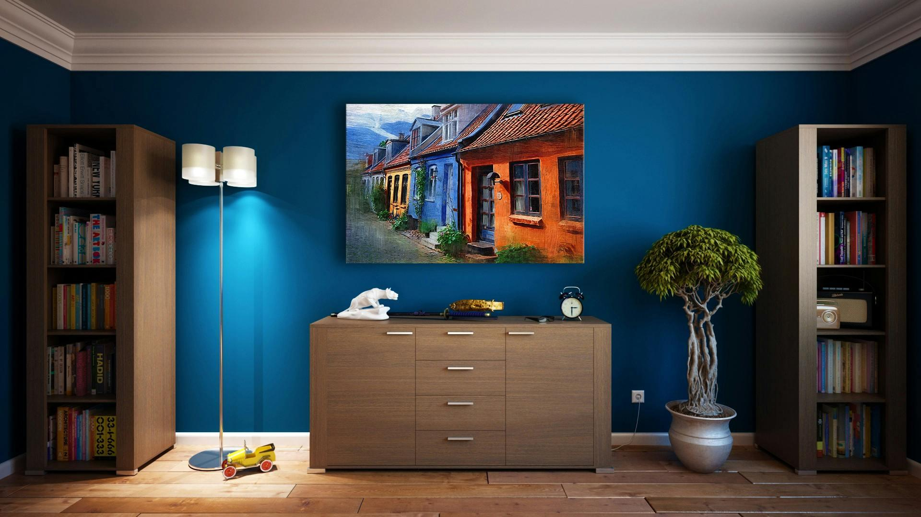

Photo via [Pexels](https://www.pexels.com/photo/gray-wooden-sideboard-271816/)

Are you looking to transform your living space without undertaking a major renovation? A few strategic changes can make a big difference. From updating your fabrics to enhancing your garden, discover how you can give your home a fresh and appealing look with these straightforward steps. Simple modifications like new curtains or a different paint color can significantly alter a room's appearance. These changes are not only easy to implement but also cost-effective. In this article, courtesy of [The Botanical Society of Lower Merion](http://www.botanicalsocietylm.org/), we’ll go over several things you can do to give your home a boost without spending a ton of money.

## **Upgrade Your Textiles**

Start with the textiles scattered throughout your home. Swapping out old bedding, towels, and table linens for fresh, new ones can dramatically [change the ambiance of your rooms](https://www.ebohemians.com/textiles-and-fabrics-guide/). When choosing new fabrics, consider textures and colors that not only reflect your personal style but also harmonize with your existing décor. This small change can rejuvenate your bedrooms and dining area, making them feel luxurious and well-coordinated.

## **Incorporate Greenery**

Nothing revitalizes a space like the addition of green plants or fresh flowers. By bringing nature indoors, you introduce color, texture, and a calming atmosphere to your home. Plants are not just decorative; they’re also beneficial for your health, purifying the air and enhancing your mood. Place a variety of plants in different areas to keep the air fresh and the décor interesting, but be sure to [consult online resources](https://homegardenhero.com/) before making your choices. This will ensure that you get plants that are both aesthetically pleasing and safe for pets/children.

## **Address Home Repairs**

Don’t let minor issues accumulate in your home. Outsource overdue repairs to professionals to maintain both function and aesthetics. You can utilize online apps to schedule these service appointments efficiently and keep track of the job progress. Integrating these appointments [with appliance repair resources](https://www.frontdoor.com/) ensures everything operates smoothly, providing a proactive approach that prevents larger problems and keeps your home in top condition.

## **Reconfigure Your Layout**

Consider the arrangement of your furniture. A new layout can transform the flow and feel of a space, making it seem like a completely new area. [Experiment with different configurations](https://www.marthastewart.com/2219858/how-arrange-furniture-best-flow-through-home) to see what makes the room feel more open or functional. Sometimes, moving a sofa or swapping the positions of your bookshelves can create a refreshing new perspective on an old space. This can be a fun and creative way to renew your living environment without spending much.

## **Make Use of Every Corner**

Look around for spaces that are currently underused, especially if you [don’t have a lot of room](https://www.boredpanda.com/efficient-space-saving-design/) to work with. Adding functional furniture such as storage ottomans or wall-mounted shelves can turn these spots into practical, stylish areas. This approach helps you declutter by providing a home for miscellaneous items while also adding a decorative touch that enhances the overall look of your space. For example, a corner can be transformed into a reading nook with just a few shelves and a comfortable chair. These small changes can make your home feel more organized and welcoming.

## **Refresh Your Outdoor Appeal**

Give your home’s exterior the attention it deserves by upgrading your landscaping. Whether it’s planting new flower beds, pruning existing plants, or adding decorative elements like stones and lighting, these changes can enhance your home’s curb appeal significantly. Well-thought-out landscaping not only adds beauty but also increases the value of your property. Consider adding seasonal plants that bloom at different times of the year to keep your garden lively. These outdoor improvements can make your home stand out in the neighborhood. Need help getting started? [The Botanical Society of Lower Merion](http://www.botanicalsocietylm.org/Resources.html) offers several resources to assist you in choosing the best plants.

## **Modernize Your Fixtures**

Replacing outdated fixtures like faucets, lighting, and showerheads can make a significant impact. Choose contemporary designs that [fit your home’s style](https://amandakatherine.com/blog/how-to-choose-right-size-style-light-fixtures/) to bring a modern touch that is visually appealing and increases functionality. This update doesn’t require a lot of time or effort, yet it instantly elevates the look of your bathrooms and kitchen.

## **Cultivate Your Garden**

If you have outdoor space, consider giving your garden a makeover. This could be as simple as introducing new plant varieties, [setting up a veggie patch](https://www.thepioneerwoman.com/home-lifestyle/gardening/g35888049/best-vegetables-to-grow/), or redesigning the entire layout. A vibrant garden creates a pleasant view and provides a relaxing hobby that beautifies your surroundings. Engaging in gardening can also be a great way to relax and connect with nature. Enhancing your garden can turn it into a tranquil retreat right in your backyard.

Revamping your home need not be daunting. With these simple yet effective steps, you can create a more inviting and stylish environment. Each change, whether large or small, contributes to a renewed space that enhances both functionality and aesthetic appeal. Start with one area, and soon you'll find the momentum to rejuvenate your entire home, making it a place you love and are proud to show off.

[*The Botanical Society of Lower Merion*](http://www.botanicalsocietylm.org/Support-Us.html) *provides a beautiful public outdoor space, and your donation and volunteerism can help. Take a look around the site today and consider making a contribution.*