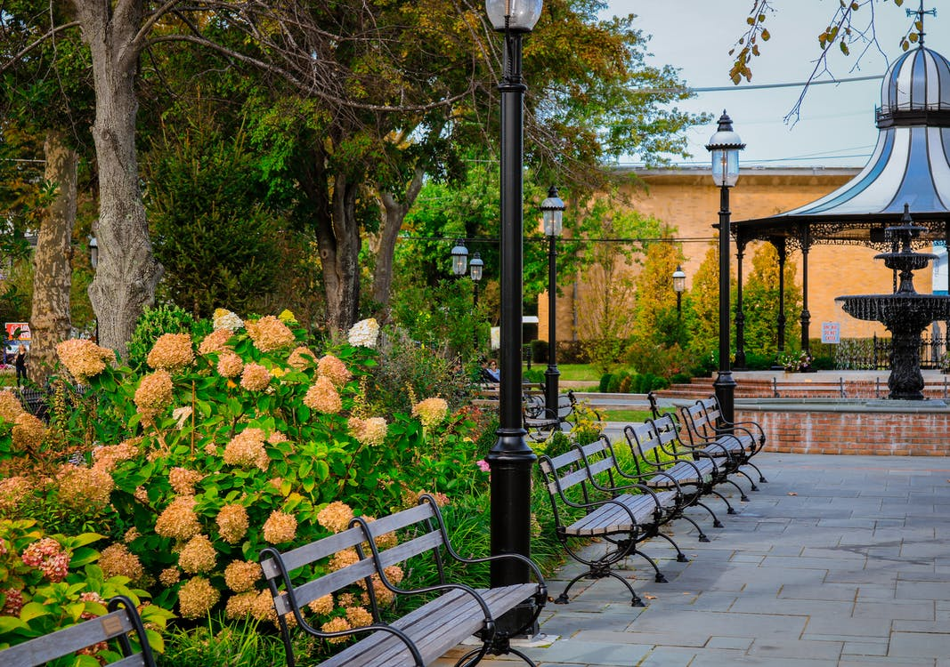
Image via Pexels

How to Be a Better Advocate for Public Parks

Public parks are wonderful for a wide variety of reasons. In addition to their aesthetic beauty and fresh air, they offer amenities ranging from playgrounds and basketball courts to hiking trails and nature centers. In fact, for those living in urban areas, the public park may be the only easily accessible access to nature available. And spending time outdoors in nature promotes both physical and mental health. Green spaces with plenty of trees help to reduce air pollution by sequestering carbon. So if you’re serious about being a better advocate for the environment, here are some suggestions and resources that may help you on your way.

Consider Becoming a Volunteer

Volunteering at a park is a great way to get involved in your community, as well as support the park. You might help with litter pickup, trail building and maintenance, removal of invasive species of plants, assist with wildlife counts, children’s activities, sports, or a special event. You’ll learn more about the wildlife in your area, meet new people, and help with many worthwhile endeavors. And if you ever decide to apply for a job in the park system, your volunteer time there will be a mark in your favor.

Advocate for Park Funding

Parks and recreation departments are often among the first areas to suffer funding cuts when city funds are in short supply. It’s important to show up at community meetings and make your voice heard. Let your representatives know that nearby parks are important to you and your community. As well as advocating for park funding, you may want to lobby for more sidewalks and lower speed limits near the park to make them more easily accessible. You’ll probably need to attend city budget meetings and bring along like-minded people to make sure the planners know what the community wants.

If you want to get even more involved, you could consider starting a nonprofit through ZenBusiness. Starting a nature-based nonprofit can be a rewarding endeavor for individuals passionate about environmental conservation and wildlife protection. Building partnerships with local communities, government agencies, and environmental organizations can also help to achieve your nonprofit's conservation goals and make an even bigger impact on your community.

Do Your Part to Promote Lighting in the Park

Good lighting is important for safety in the park. This includes areas from the parking lot to entrances, walkways, and nature centers, as well as any other places that are regularly used. Park visitors will feel safer visiting well-lit open spaces, as good lighting reduces crime and fear of crime. If your local parks could use better lighting, you might want to contact the parks and recreation department to discuss fundraising specifically for better lighting. Outdoor lighting is different from that designed for indoors. Lamp posts must be sturdier, weatherproof, and resistant to vandalism.

Help with Fundraising

Planning a fundraising event is important. The needed improvements and goals should be clearly delineated and presented in such a way that potential donors can easily see what they’ll be supporting. It’s important to build a team of people, of all ages and different walks of life, who care about the park. You can participate in organizing, publicizing, and conducting events that fundraise for the parks in your area. Whether you’re posting flyers, directing parking, selling lemonade, directly soliciting contributions, or assisting in some other capacity, lending your effort will help improve the park and your community.

Becoming an advocate for parks in your community can have many positive effects. You’ll benefit from knowing you are part of a worthwhile endeavor, and you’ll meet more people, get to spend more time in the park, and help enhance your community. Of course, you’ll also benefit from any improvements you help foster. In a very real way, well-maintained public green spaces and parks reduce crime and air pollution. They also encourage people to move more, exercise, and spend time outdoors, which all contribute to enhanced physical and mental health. A local park can foster a feeling of community in the neighborhood, too. Your efforts will improve both the present and the future in positive ways.

The Botanical Society of Lower Merion is here to make our community a little brighter. Questions? Feel free to email botanicalsocietylm@gmail.com.

